nagavel.rajagopal

navigate to project root directory and run the following command to cretae the image

docker build -t {dockerName}/{imagename} .

docker logs -f {container ID} to check logs

docker run -p hostport:containerport -d <image name>

docker run -p 8089:8081 -d docker950/weatherr

docker push <image Name>:<TAG>

kubectl config set-context docker-desktop

kubectl rollout undo deployment/weather --to-revision=1

kubectl rollout history deployment/weather

<https://12factor.net/>

<https://chrisrichardson.net/post/antipatterns/2019/01/28/melbourne-microservices.html>

FROM openjdk:8-jdk-alpine

RUN addgroup -S spring && adduser -S spring -G spring

USER spring:spring

ARG JAR_FILE=target/*.jar

COPY ${JAR_FILE} app.jar

ENTRYPOINT ["java","-jar","/app.jar"]

FROM openjdk:11-jdk-oracle

ARG JAR_FILE=target/*.jar

COPY ${JAR_FILE} app.jar

ENTRYPOINT ["java","-jar","/app.jar"]

**MicroService Definition**

Micro service is a architectural style , where we decompose our application into independent services that are loosely coupled.

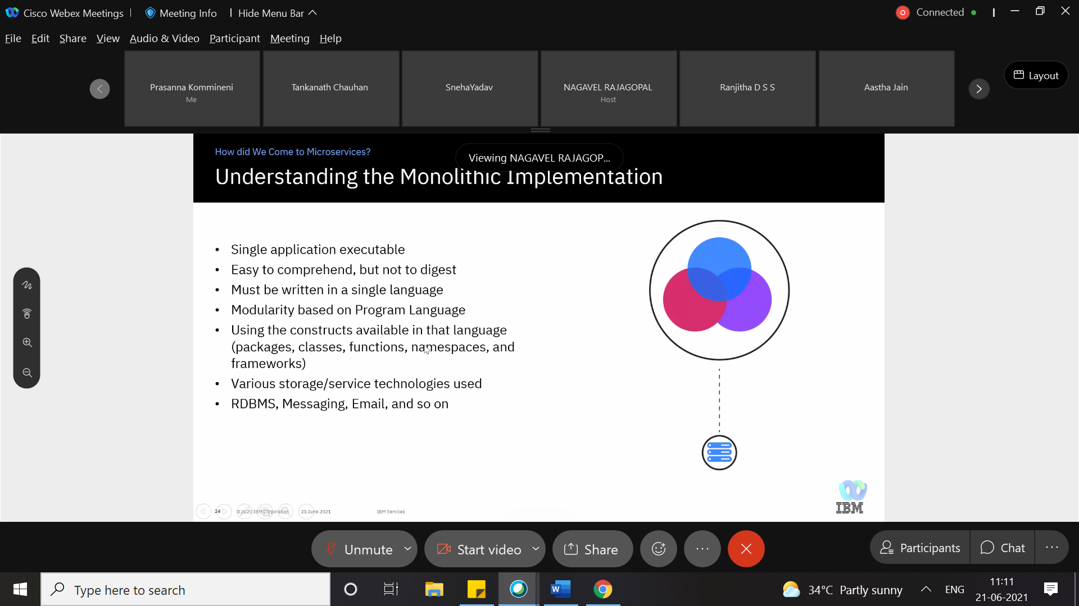

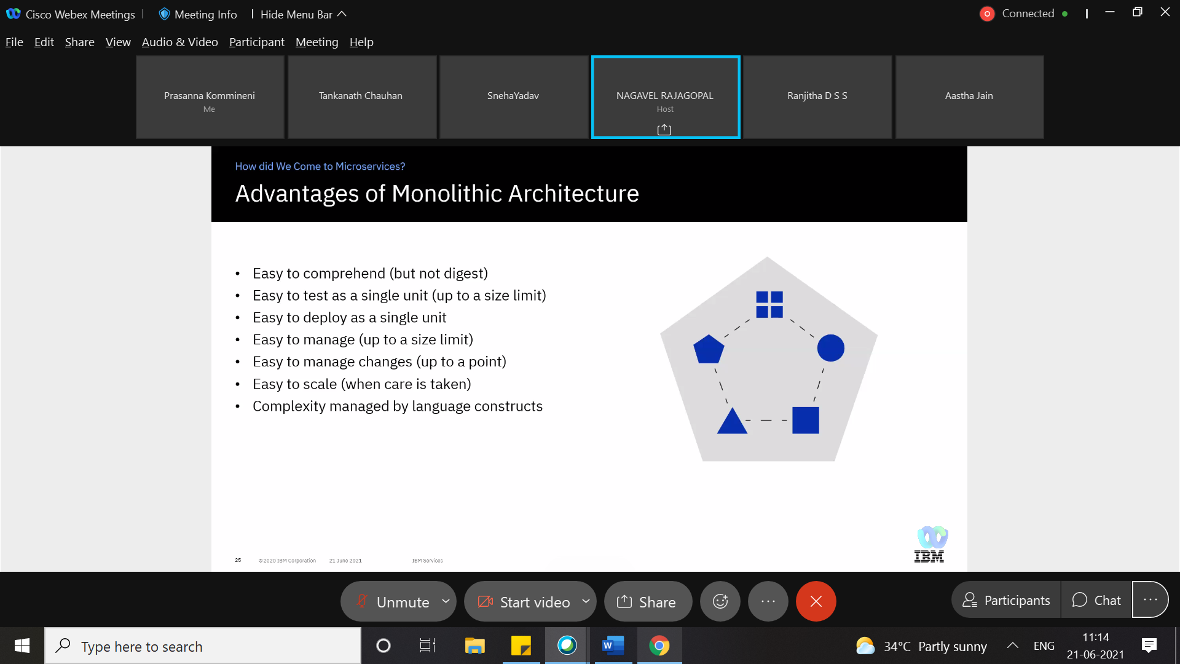

<https://martinfowler.com/articles/microservices.html>

**REST API**

Representational state transfer

It is architectural style designing of loosely coupled application over http

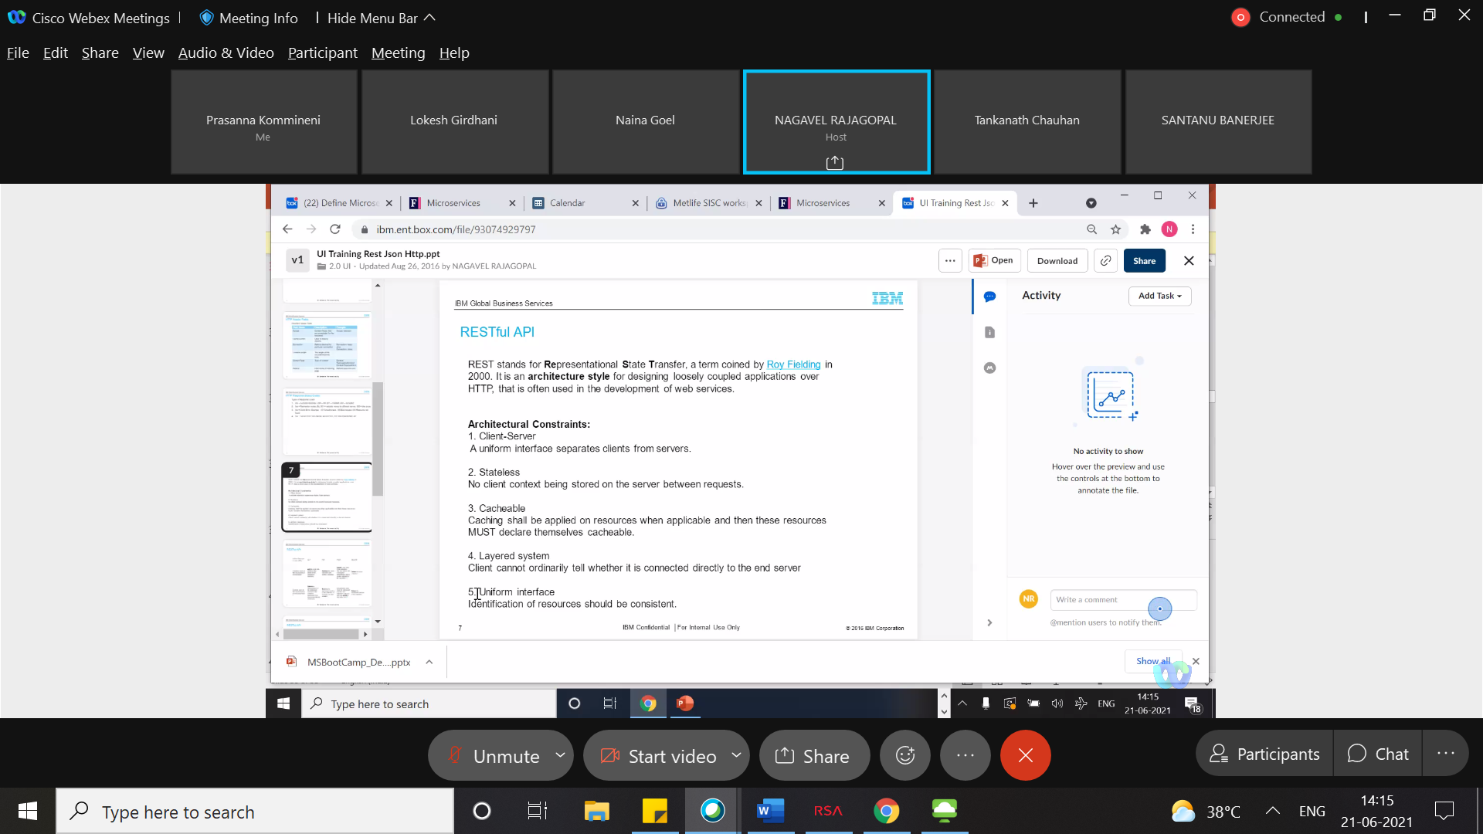

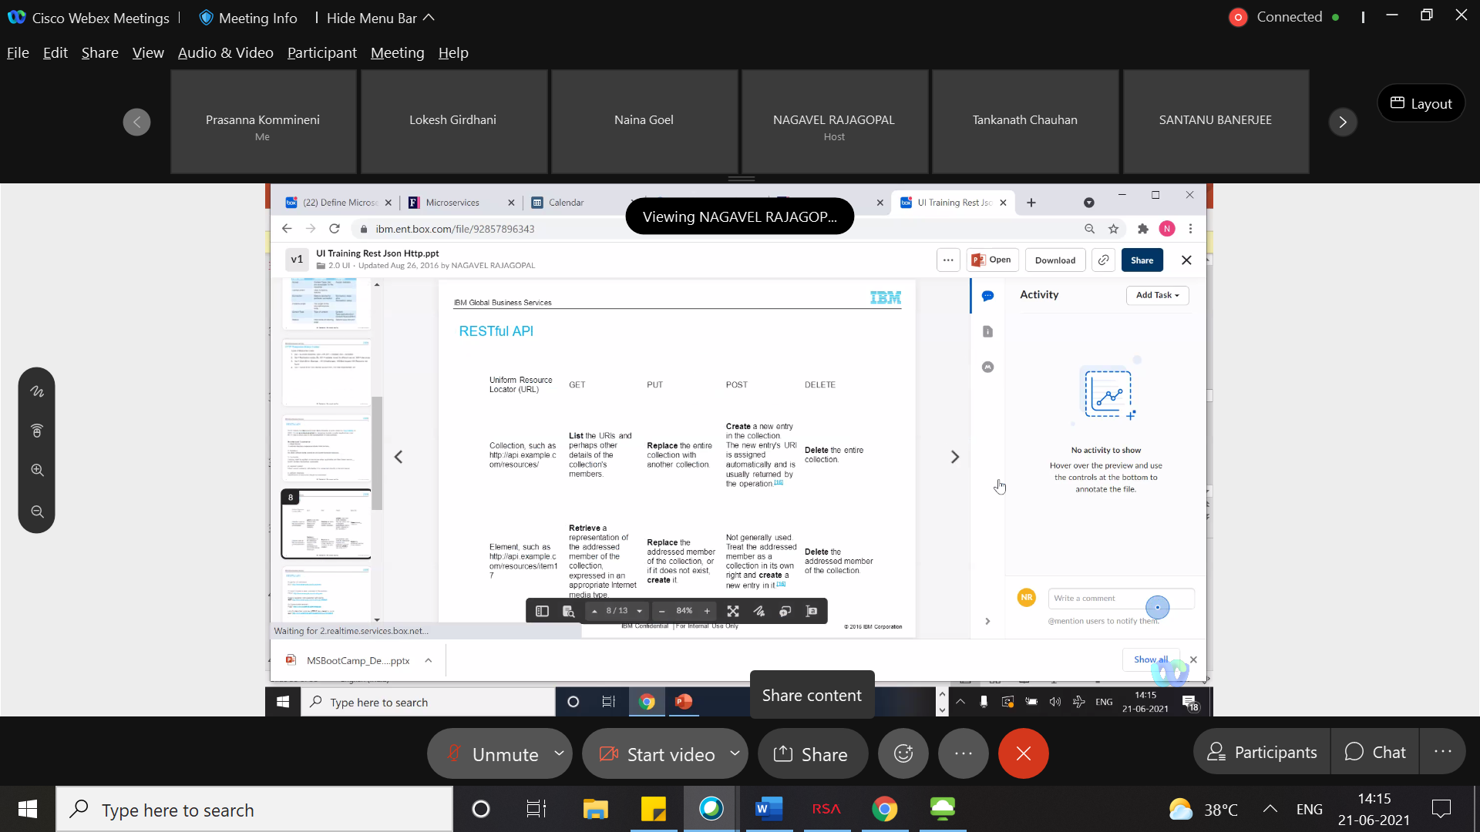

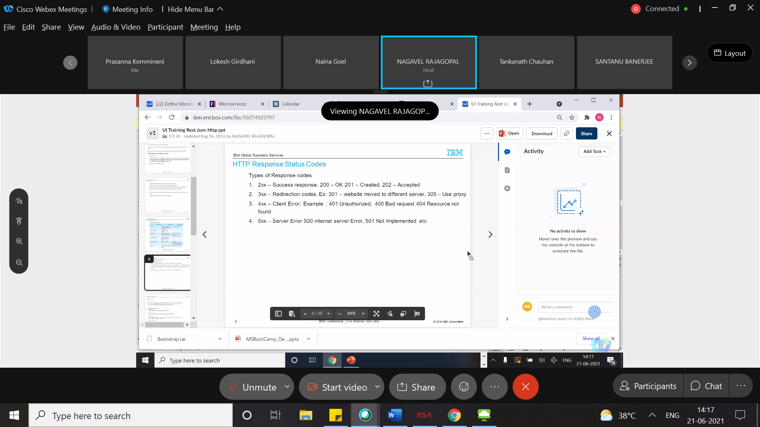

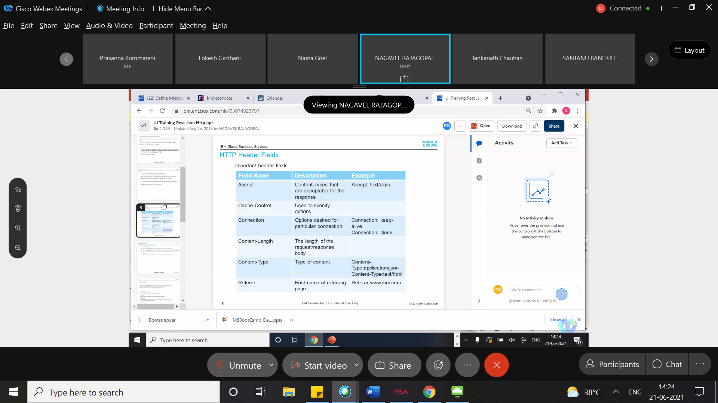

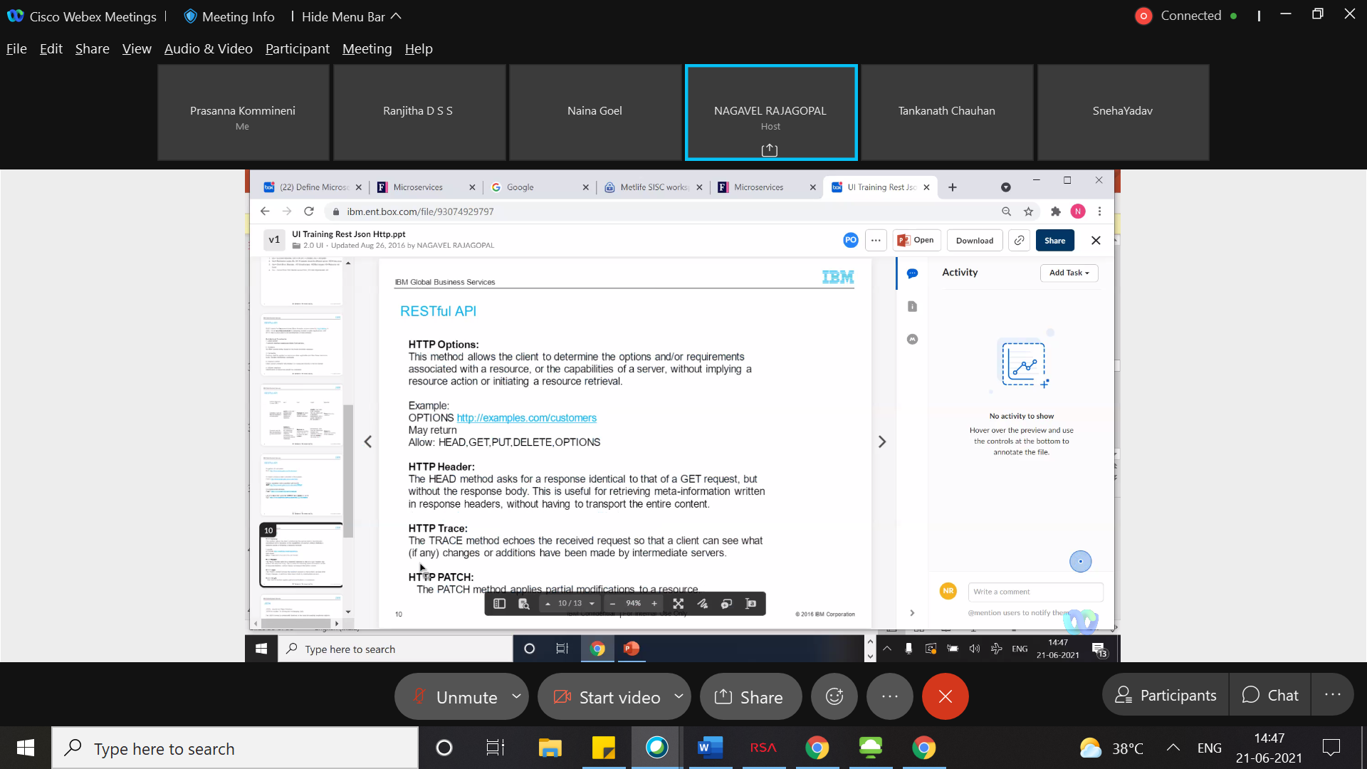

Most of the UI applications can accept the json without any parser.

Browser can unsderstand json better than xml.

Any restful URI should be plural

**Difference b/w put & post**

We will use post to create to new entry(when we have no idea on resource id )

We will use put to update the existing record

Dispatcher servlet is front controller of web app

**Optional Classs**

If we are not sure about the result ,result will be wrapped in optional class .(it may return result or null)

Add a crud repository

Create and find by Id

Id,name,isbn,price

<https://ibm.webex.com/ibm/url.php?gourl=https%3a%2f%2fgithub%2eibm%2ecom%2fnagavel%2drajagopal%2fspring%2dtraining>

Spring started as a framework and over the time it evolved into a platform(which provides everything to develop an application)

**@springbootapplication is combo of following annotations**

@enableautoconfiguration,@componentscan,@

Enable autoconfiguration ,it will scan all the classpaths and injects the beans(db config)

@componentscan it will scan the classe from current(root) package and subpackages ,we can create our own annotations to customize the behaviour

Microservices should have monitoring , continuous deployment(rapid delivery CI/CD), rapid servers

Promothios,graphana for monitoring the app and infrastructure

**Actuator** provides production ready monitoring for spring boot application

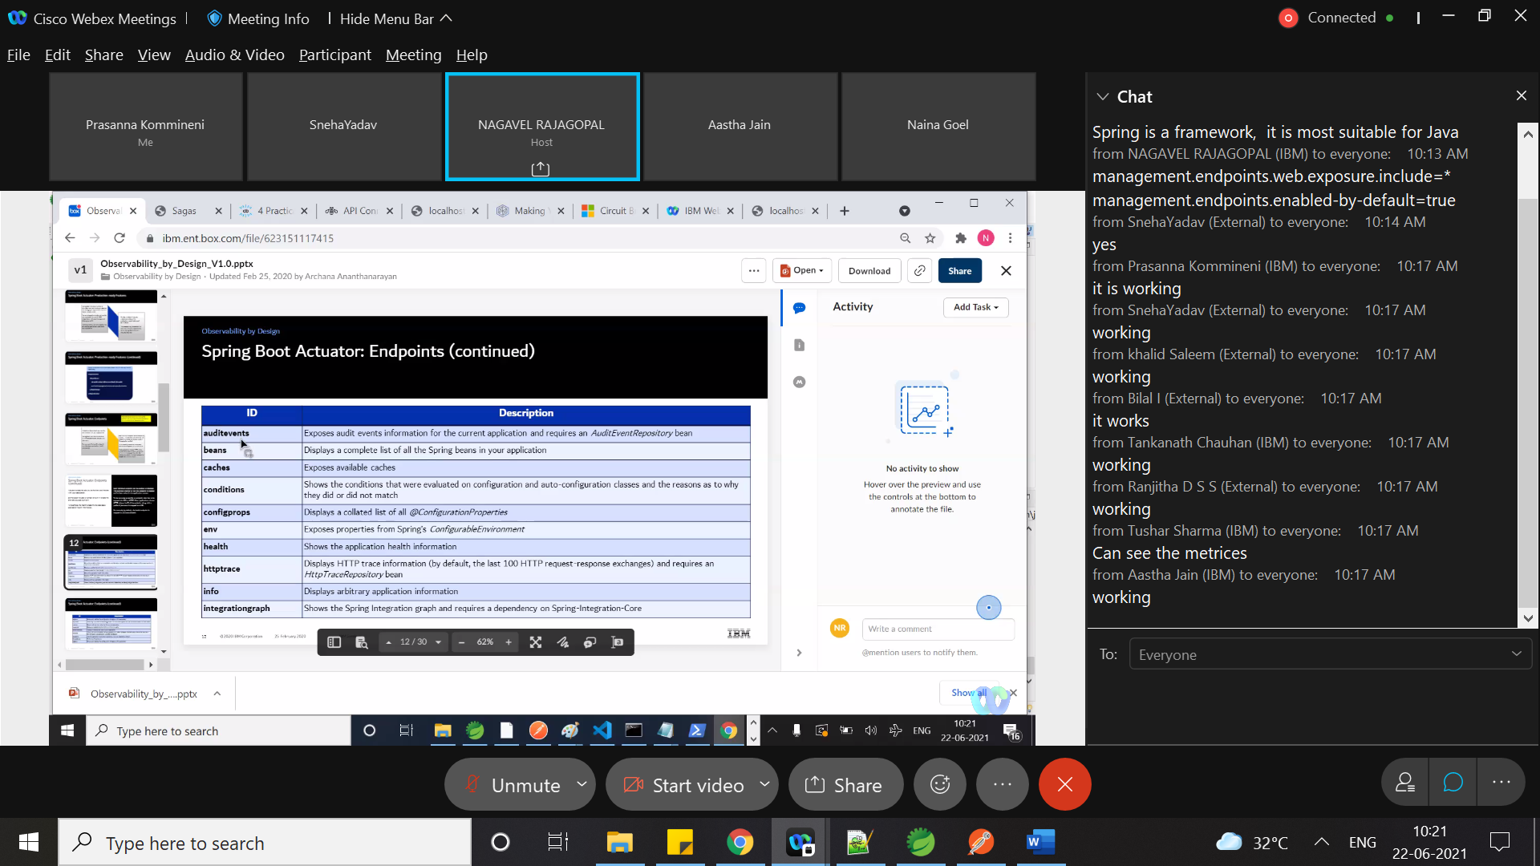

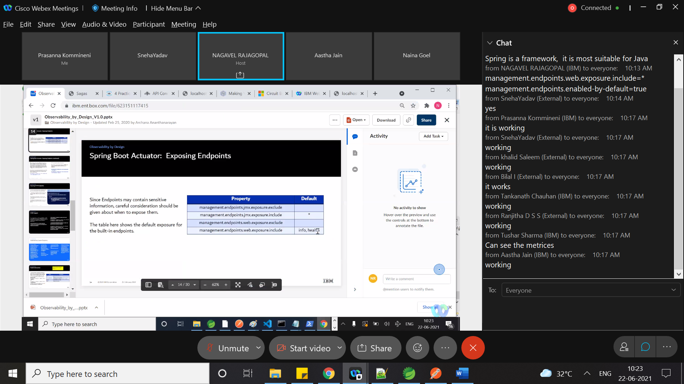

**ApiGateway**

**It acts** as a backend for UI

It can transfer the protocol(HTTP<=>AMQP,)

It can throttle the requests(like 50 reqs per second)

We can aggregate the services in api gateway

We can have different api gateways for mobile,web and external client

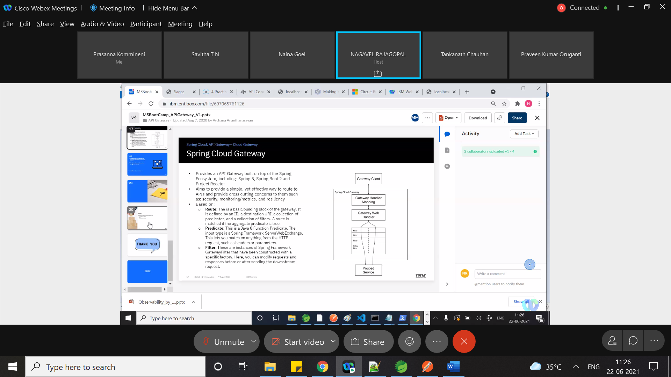

**Spring API GAteWay**

Route,predicate,filter

**Eureka**

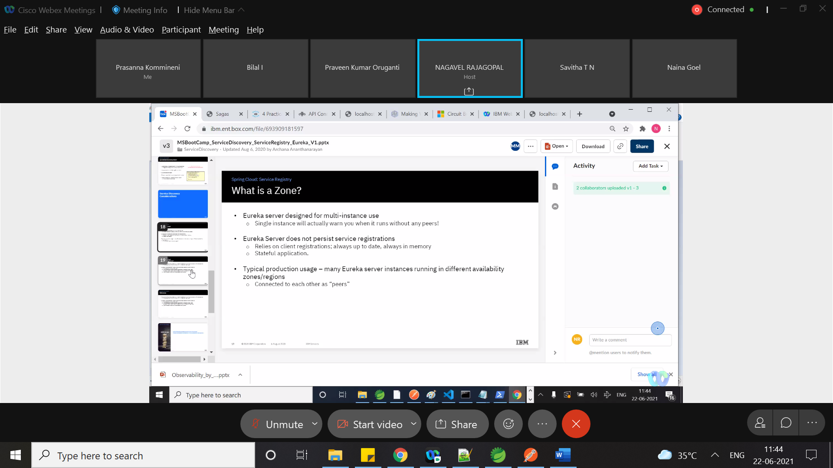

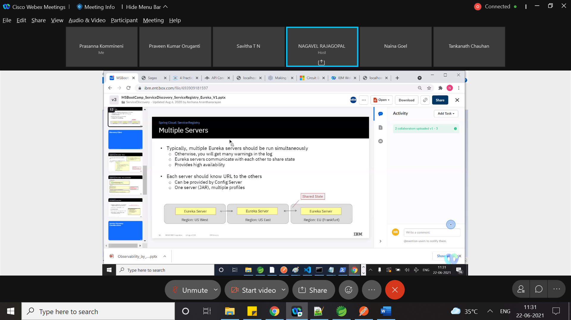

**Circuit Braker:**

Failure in one service is cascading to failure in other services.

Circuit breaker helps to fail fast.if the service is failing more than threshold times ,next time it is not going to call the service and it will fail without calling.circuit breaker will not prevent the failure.

This can be implemented by Netflix hystrix

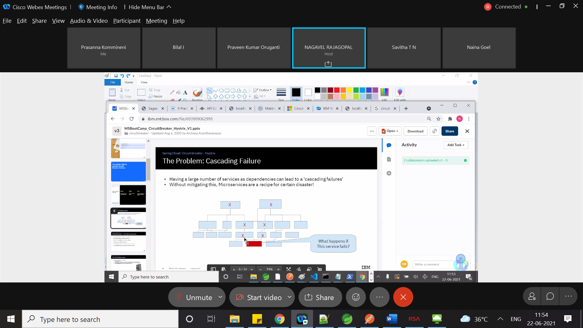

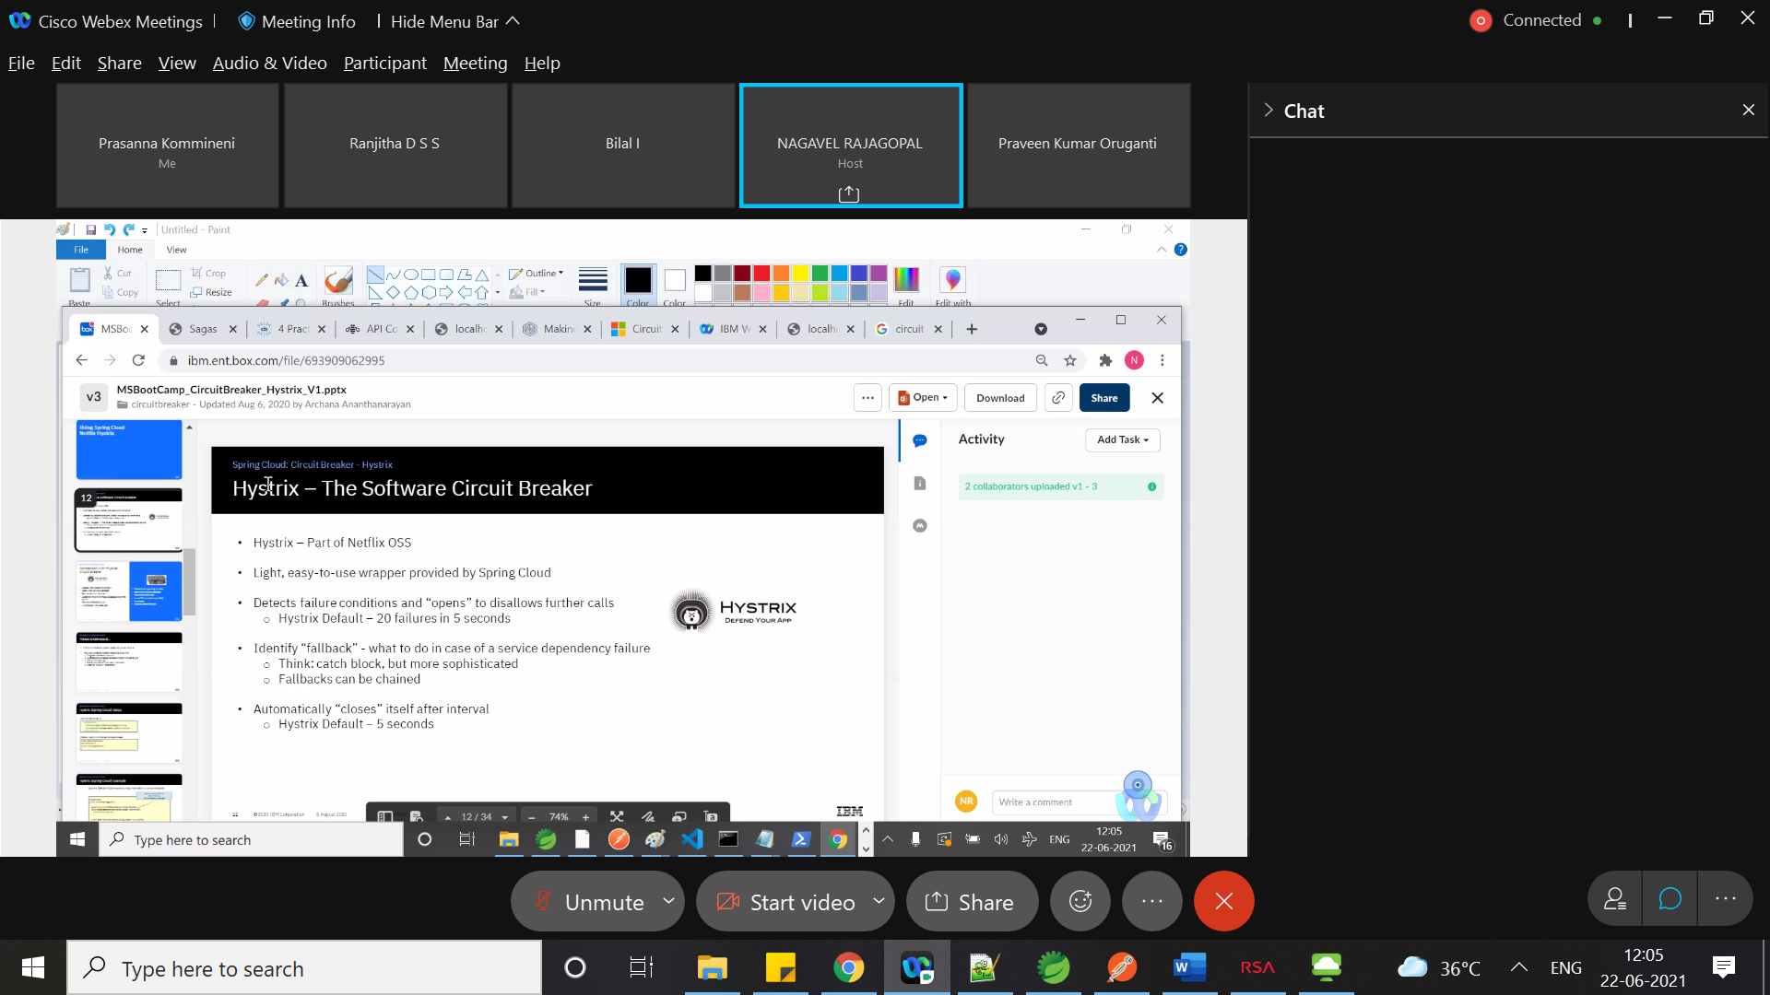

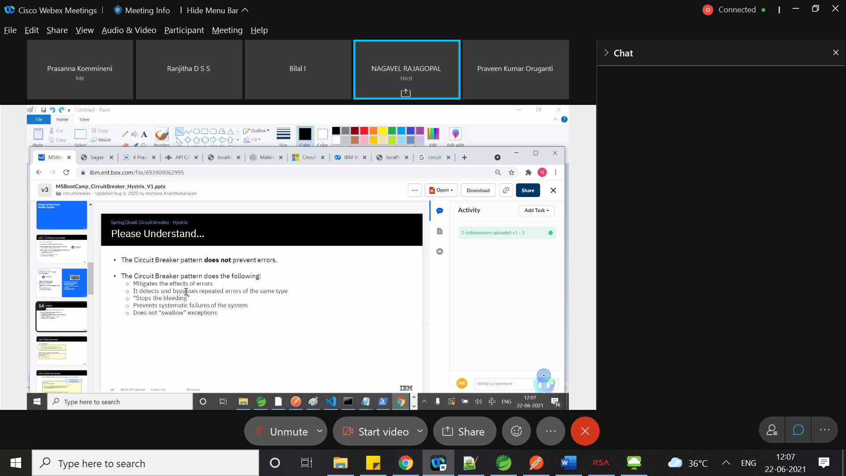

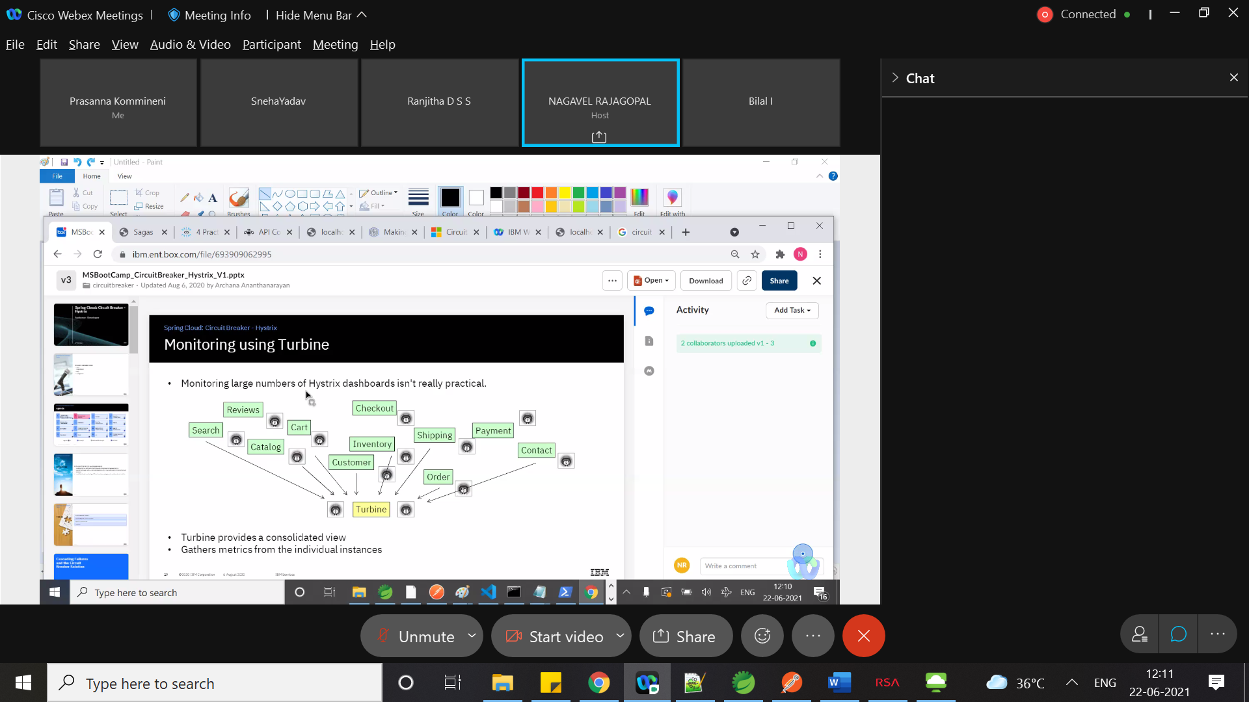

Bulk Head(design for Failure)

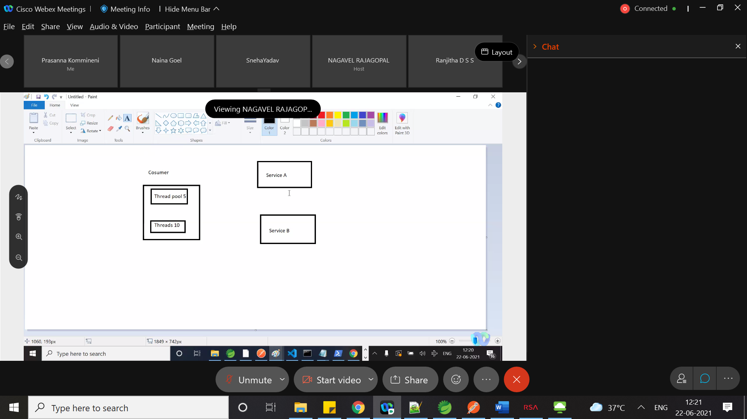

We are not affecting the failure of one service in interaction with other service(we are giving dixed no of thread pools , so that all threads will not be busy in connect with the failing service)

Bulk heads another scenario

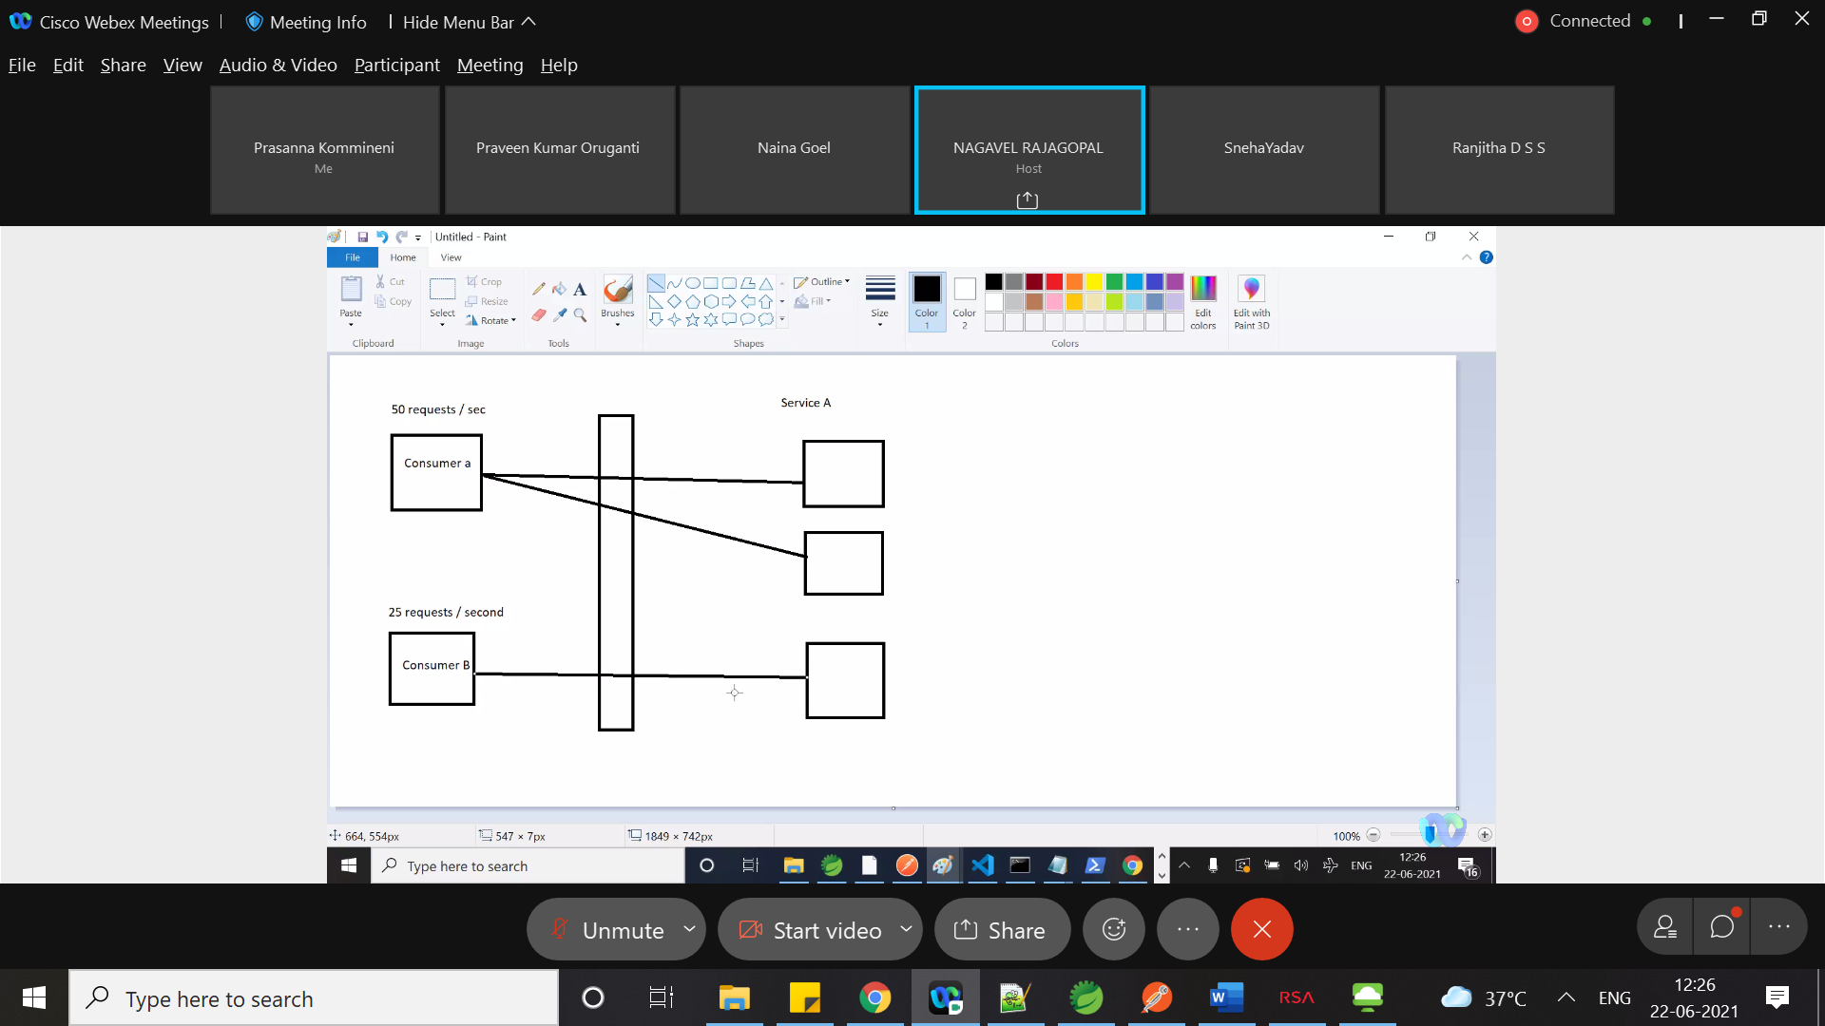

**Load balancing**

Ribbon client,Netflix

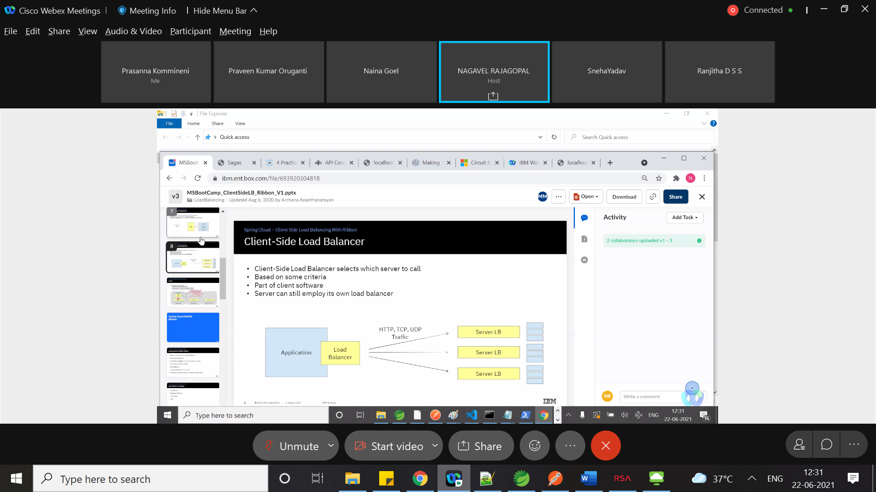

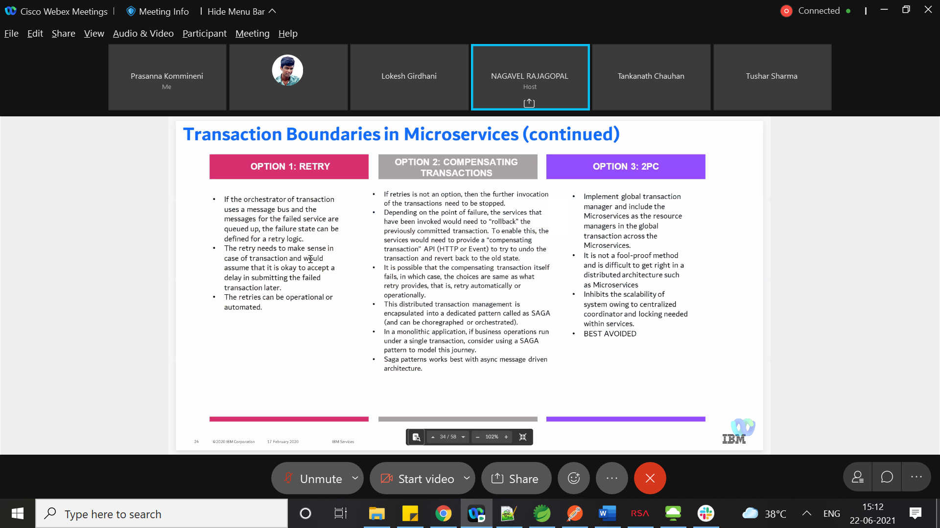

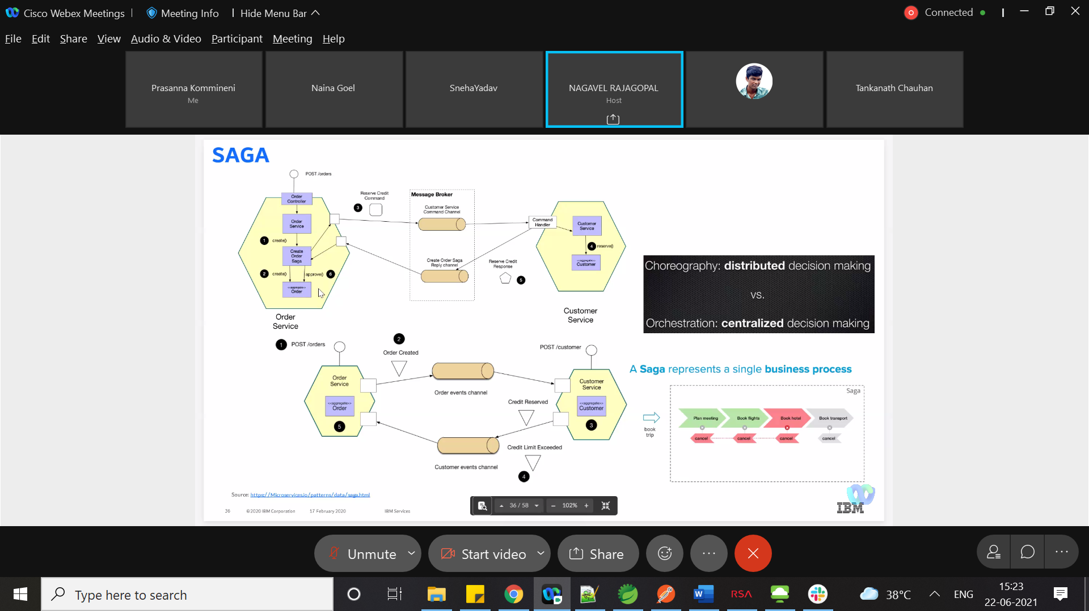

Container is running instance of image

Image is read only package

We will push our images to registr(docker hub).stores ,shares and distributes the container images

Docker engine runs and creates the container

Docker file is a document that has instruction that docker engine can understand and build the container

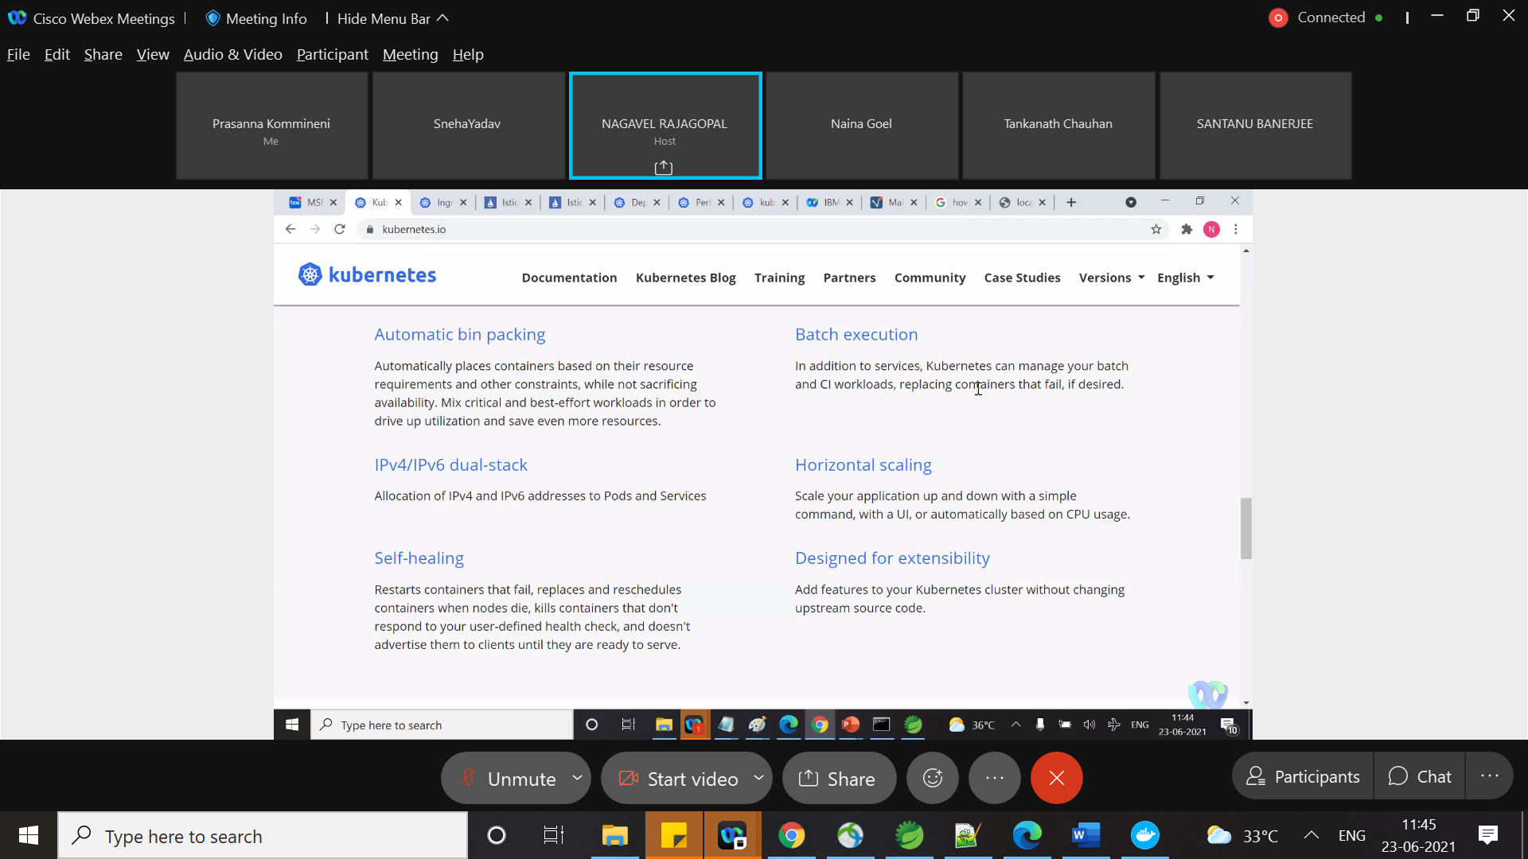

Kubelet is responsible for creating pods